Water Resources Research
Supporting Information for
Farms, fish, and cost: stakeholder-driven scenario design and objective functions clarify trade-offs in an active local water planning process, Northern California Claire Kouba¹, Leland Scantlebury², Thomas Harter³
1 Yale School of the Environment, Yale University, New Haven Connecticut
2 Hydrologic Sciences, University of California Davis, Davis California
3 Land Air and Water Resources, University of California Davis, Davis California

Contents of this file

Text S1
Figures S1 through S18
Tables S1 to S8
Movies S1 to S4

Additional Supporting Information (Files uploaded separately)

Captions for Data Sets S1 to S4
Introduction
Text S1 contains additional methods details regarding the Hydrologic Benefit Function(s) used in this study.
Figures S1 and S2 contain general information regarding a subset of water management scenarios.
Figures S3-S18 contain supplemental figures illustrating the study results based on four different Hydrologic Benefit (HB) Function formulations, which were based on four different ecological response units: coho juvenile abundance, coho juveniles per spawner, Chinook juvenile abundance, and Chinook juveniles per spawner (HB Functions A-D, respectively).
Tables S1-S4 contain the coefficients in Hydrologic Benefit Functions A-D, respectively.
Tables S5-S8 each contain tabulated model results for all 25 management scenarios, for Hydrologic Benefit Functions A-D, respectively.
Data Sets S1-S4 (uploaded separately as files starting with notations ds01-ds04) contain the annual functional flow values, for water years 1991-2025, used to calculate the value of Hydrologic Benefit Functions A-D, respectively, for four example scenarios. Captions for these tables are found at the end of this Supporting Information document.

Text S1.

Methodological details of Hydrologic Benefit function formulations
The Hydrologic Benefit (HB) function is intended to estimate the ecological value (in units of fish production) provided to fish by specific flow values (e.g., timing of fall flow increase; magnitude of dry season flow). This is expressed in conceptual mathematical terms as $fish=b+m_{1}*flow_{1}+m_{2}*flow_{2} ⋯$ ; see methods in Kouba et al. (2025) for more details. It’s important to note that, in this dataset, only 40-60% of variation in fish outcome was explained in models based on flow data, and the HB function does not constitute a prediction of the number of fish outmigrating in a given year.
While Kouba et al. (2025, Table 2) identified twelve HB functions, the results below are based on only four of those statistical models, all using LASSO regression, of reproductive output for two species of salmon (coho and Chinook) in the Scott River stream system. Reproductive output is expressed in units of outmigrating juvenile abundance and normalized juveniles-per-adult spawner; two reproductive units for two species yields the four HB function formulations.
While MARSS models were used as a tool for identifying important functional flows in (Kouba et al. 2025), they are unsuitable for this hydrologic scenario outcome forecasting purpose, due to the nature of autoregression: the forecasting of future fish outcomes requires historical observations of fish outcomes. Therefore, to use MARSS models in estimating the ecological effects of flow changes under different management scenarios, it would be necessary to have historical fish records collected in an alternate reality under the different management scenarios, which is not possible. Similarly, LASSO models which included spawner abundance as a predictor were also not included in this exercise (see Table 2 in Kouba et al., 2025).
Consequently, only LASSO models dependent on hydrologic variables were evaluated as potential tools to forecast the outcomes of flow change on fish reproduction.
For each species, across all statistical methods, the coefficients for any single predictor were consistently negative or positive; e.g., more coho reproduction was consistently associated with earlier fall reconnection.

Reference

Kouba, Claire, Leland Scantlebury, Jason Wiener, Sarah Yarnell, and Thomas Harter. 2025. “A Watershed-Specific Approach to Identify Key Functional Flow Metrics Supporting Salmon Reproduction.” Ecohydrology : Ecosystems, Land and Water Process Interactions, Ecohydrogeomorphology 18 (5): e70098. https://doi.org/10.1002/eco.70098.

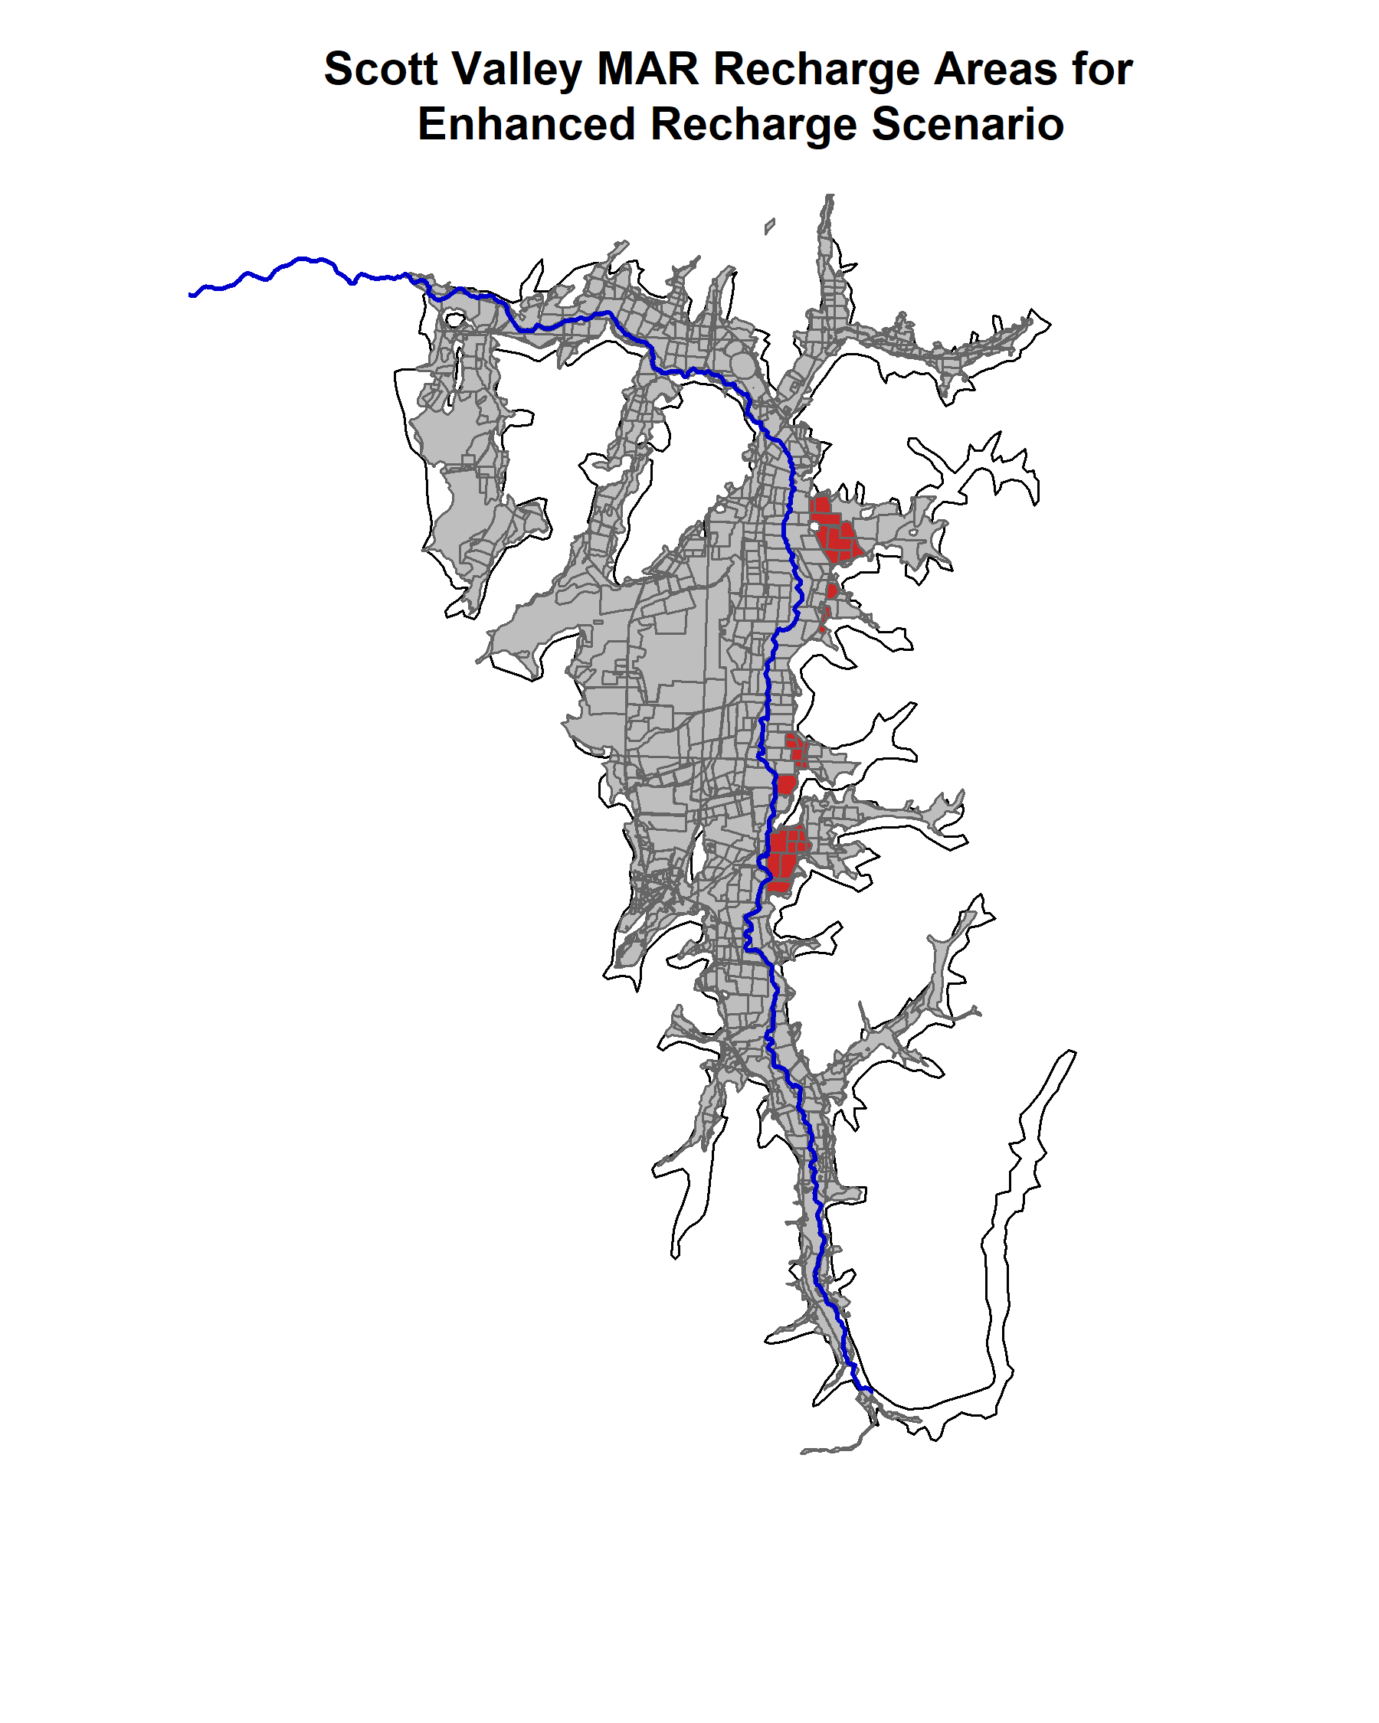

Figure S1.

Fields used in the 2024 MAR recharge pilot program are highlighted in red. These fields were used to specify areas where winter recharge (Jan-March) was applied each year in the Enhanced Recharge scenario.

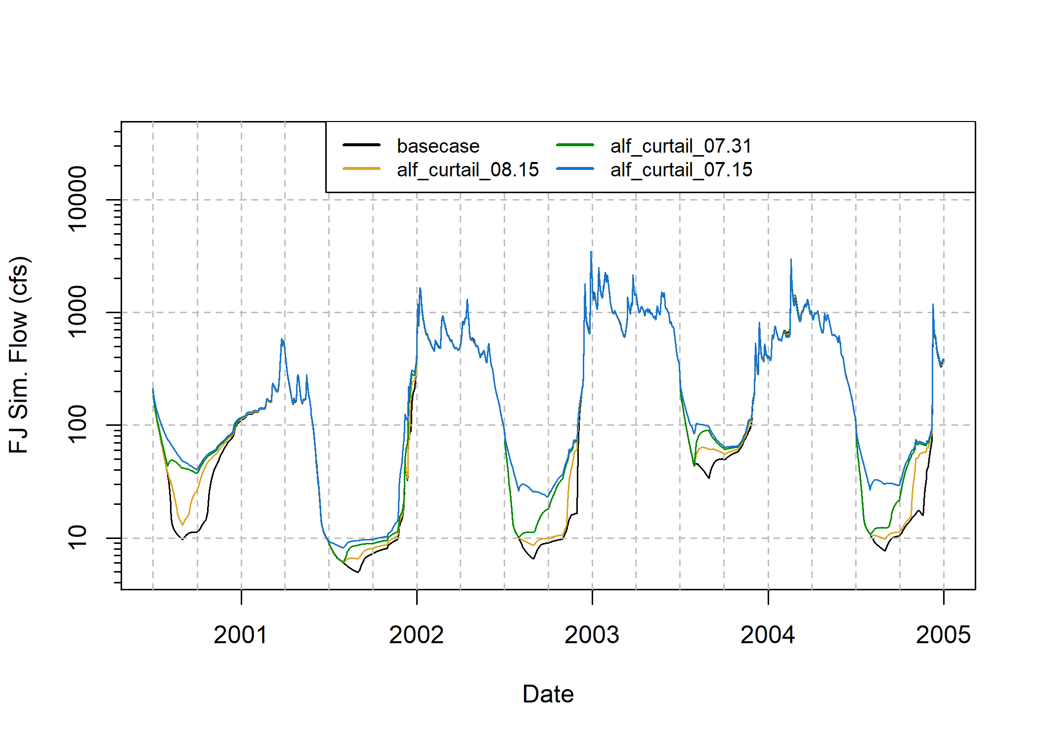Figure S2.

Example scenario impacts on river flow: simulated FJ daily average flow (the basis for functional flows, which is the basis for HB function values) for multiple scenarios.

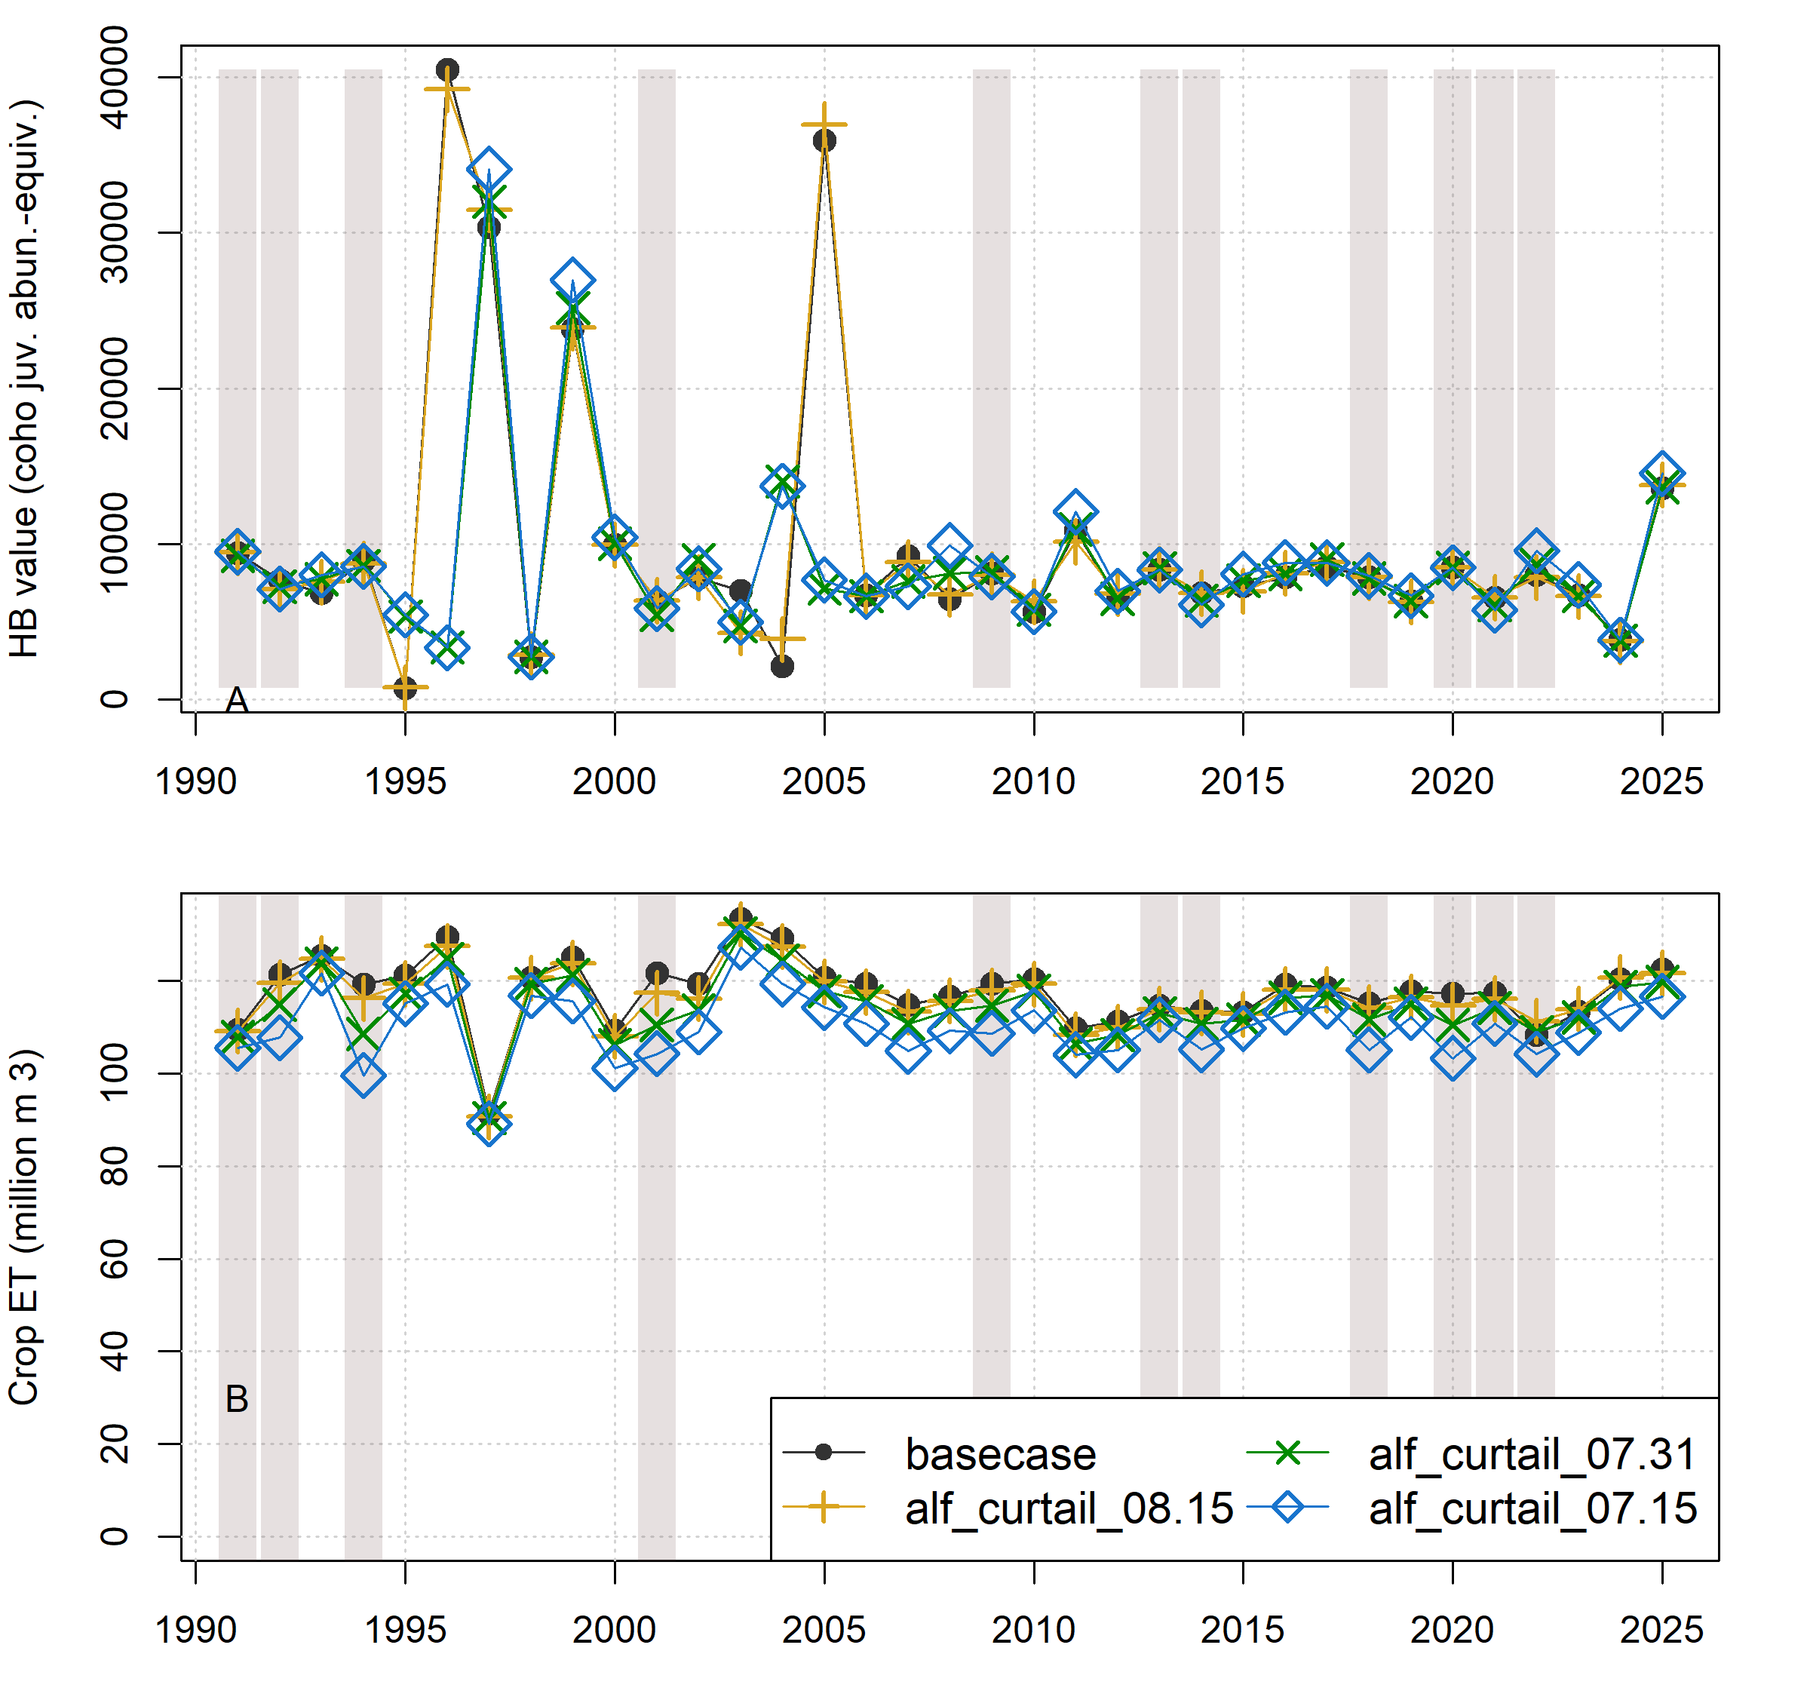Figure S3.
Comparison of annual performance in two objective functions (Hydrologic Benefit A and ET, representing environmental and agricultural objectives, respectively) for brood years 1991-2025. The scenarios pictured are base case (black circles) and a scenario from each of three categories: Enhanced Recharge, Crop Change, and Native Vegetation (Low ET). Dry-type water years (vertical bars) are 1991, ’92, ’94, 2001, ’09, ’13, ’14, ’18, and ’20-’22.

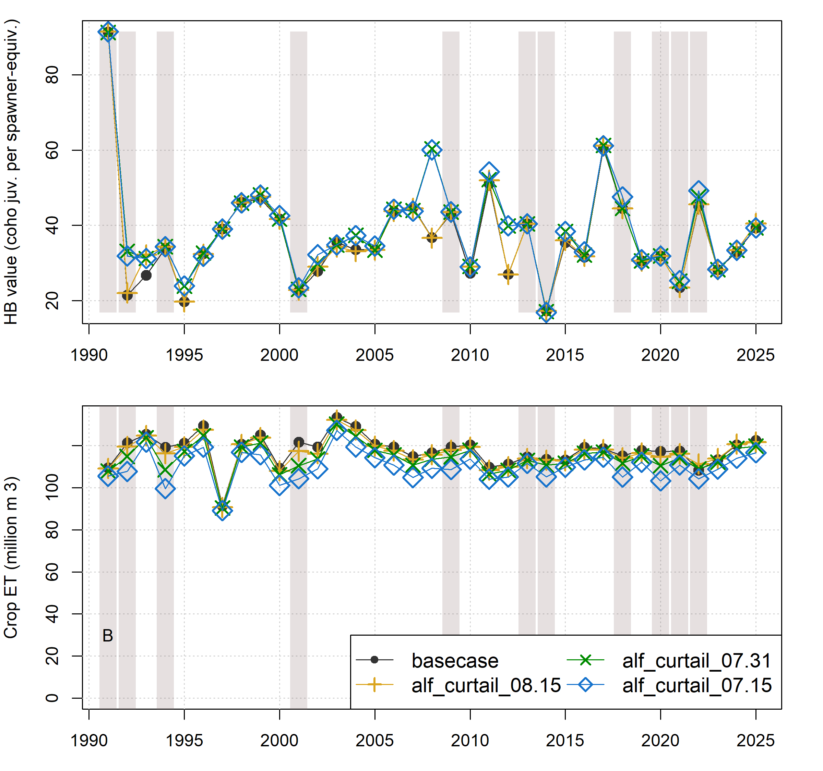Figure S4.
Comparison of annual performance in two objective functions (Hydrologic Benefit B and ET, representing environmental and agricultural objectives, respectively) for brood years 1991-2025. The scenarios pictured are base case (black circles) and a scenario from each of three categories: Enhanced Recharge, Crop Change, and Native Vegetation (Low ET). Dry-type water years (vertical bars) are 1991, ’92, ’94, 2001, ’09, ’13, ’14, ’18, and ’20-’22.

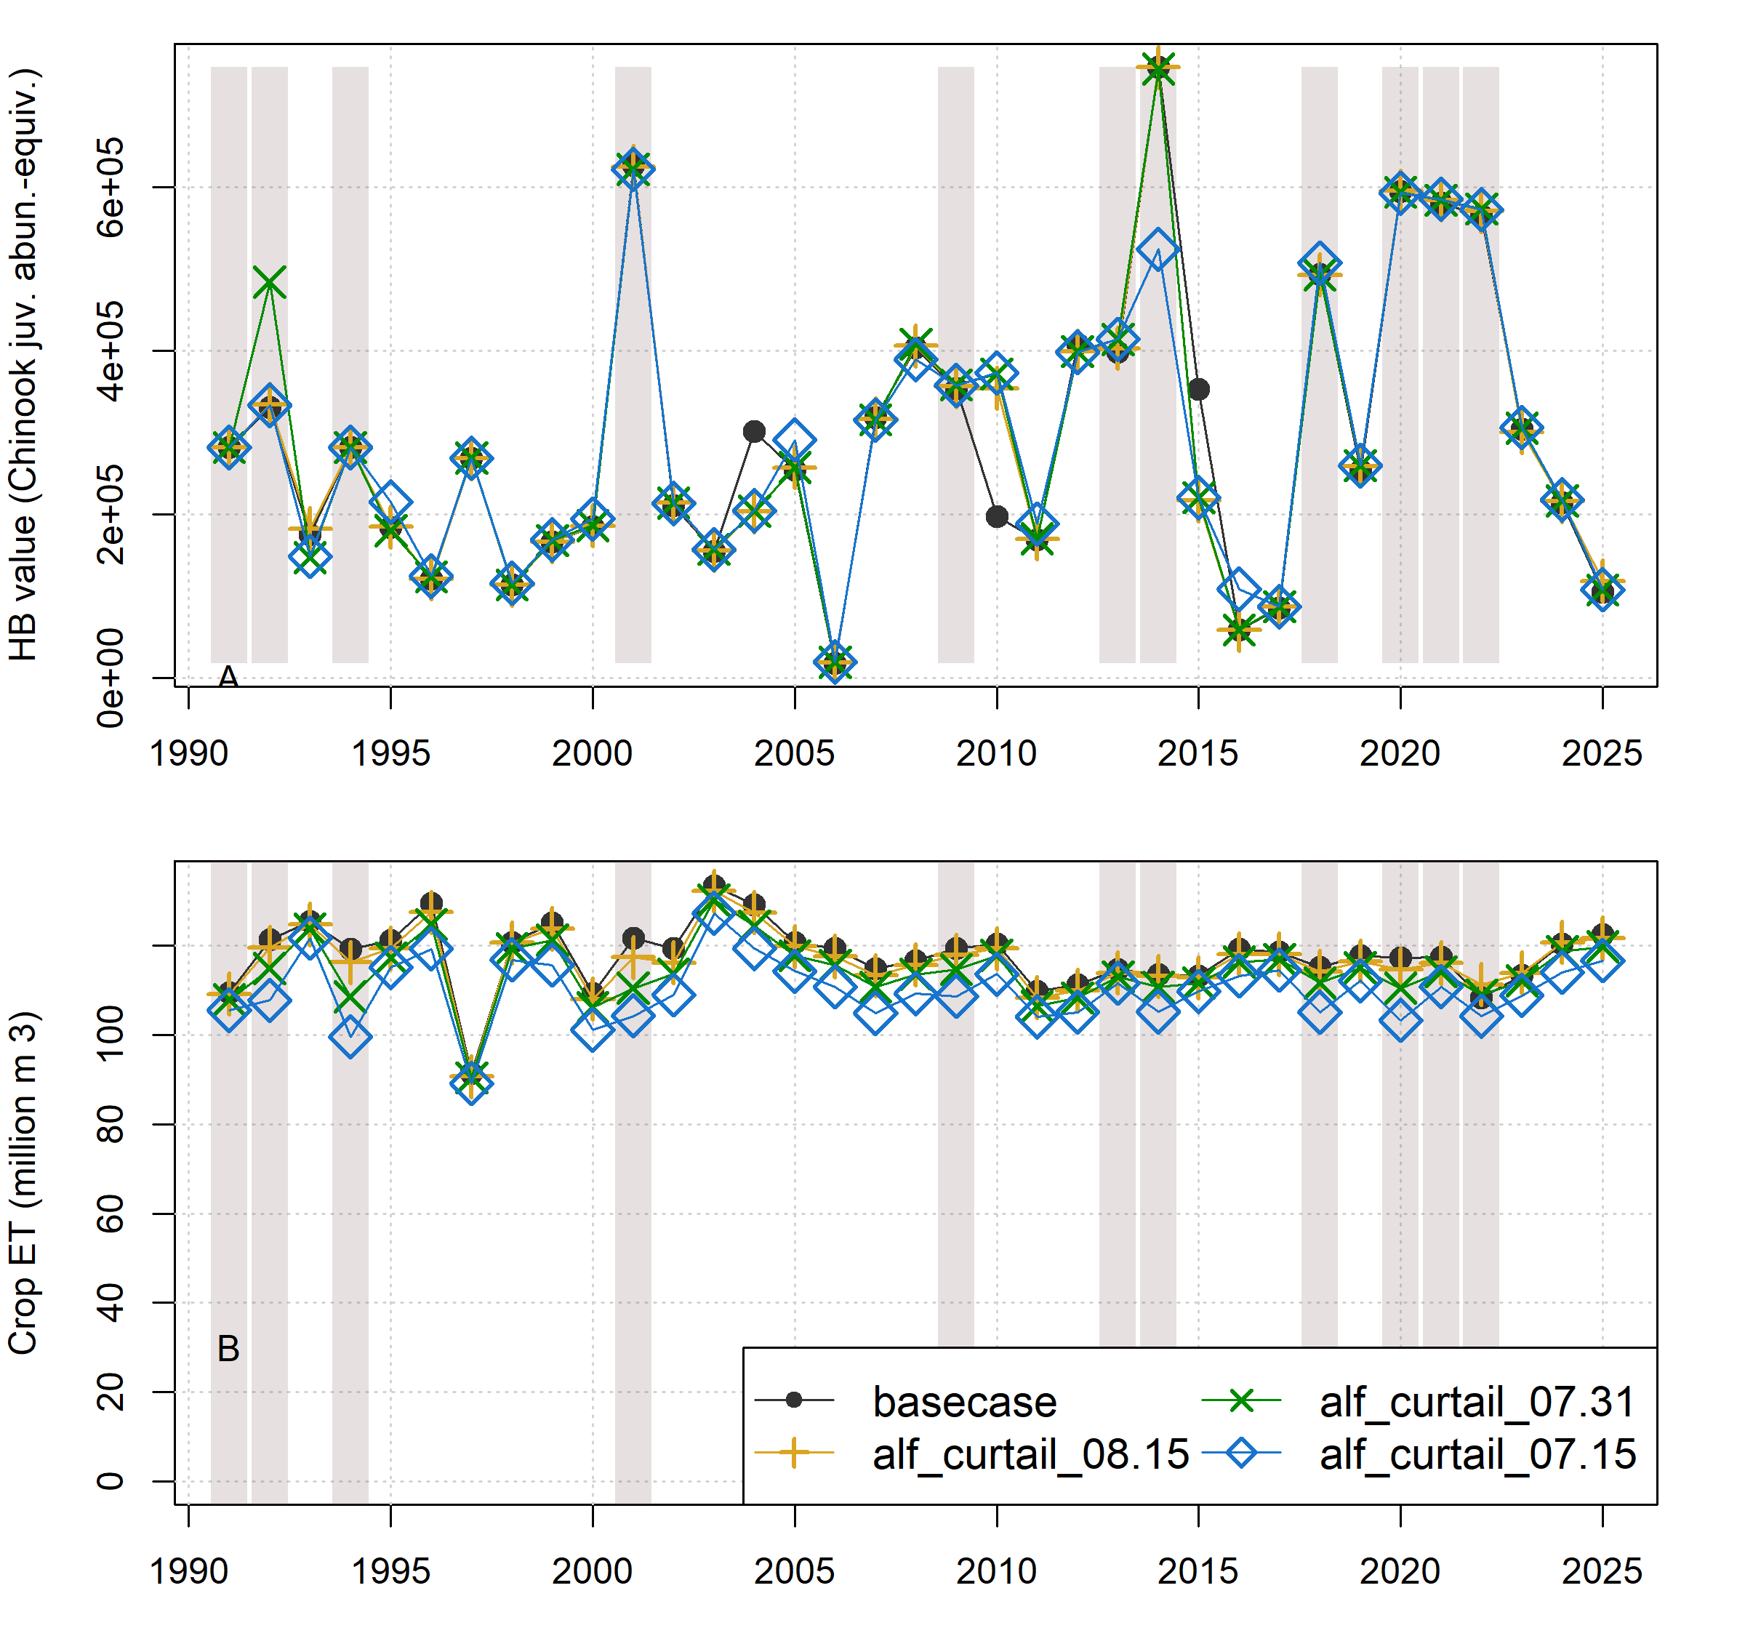Figure S5.
Comparison of annual performance in two objective functions (Hydrologic Benefit C and ET, representing environmental and agricultural objectives, respectively) for brood years 1991-2025. The scenarios pictured are base case (black circles) and a scenario from each of three categories: Enhanced Recharge, Crop Change, and Native Vegetation (Low ET). Dry-type water years (vertical bars) are 1991, ’92, ’94, 2001, ’09, ’13, ’14, ’18, and ’20-’22.

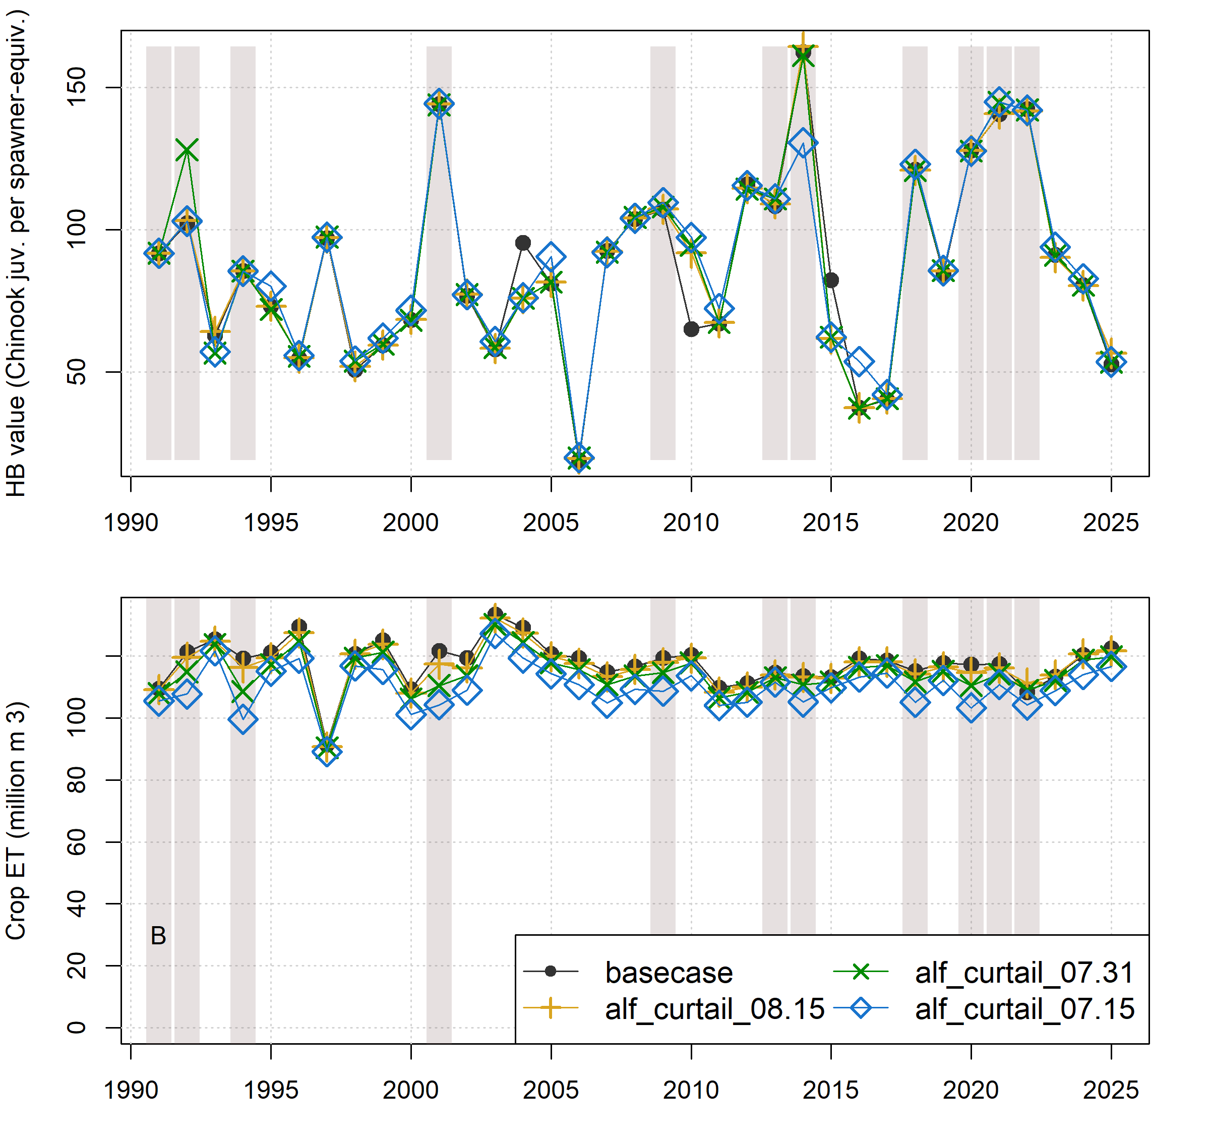Figure S6.
Comparison of annual performance in two objective functions (Hydrologic Benefit D and ET, representing environmental and agricultural objectives, respectively) for brood years 1991-2025. The scenarios pictured are base case (black circles) and a scenario from each of three categories: Enhanced Recharge, Crop Change, and Native Vegetation (Low ET). Dry-type water years (vertical bars) are 1991, ’92, ’94, 2001, ’09, ’13, ’14, ’18, and ’20-’22.

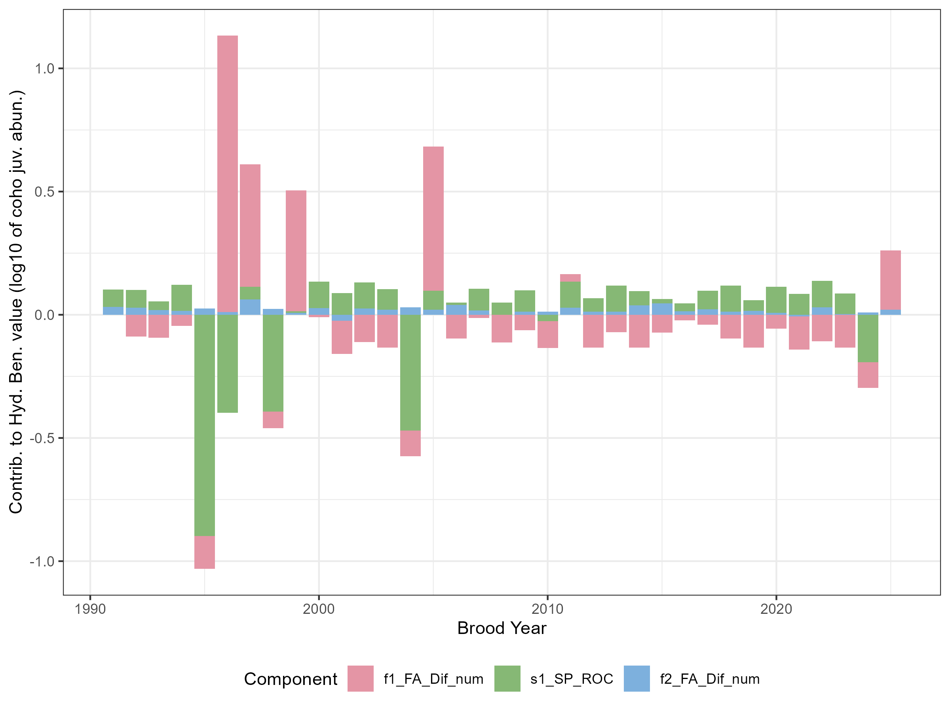Figure S7.
For the base case scenario, contributions to annual Hydrologic Benefit Function A values, by functional flow metric (see Table 1 above; intercept values not shown).

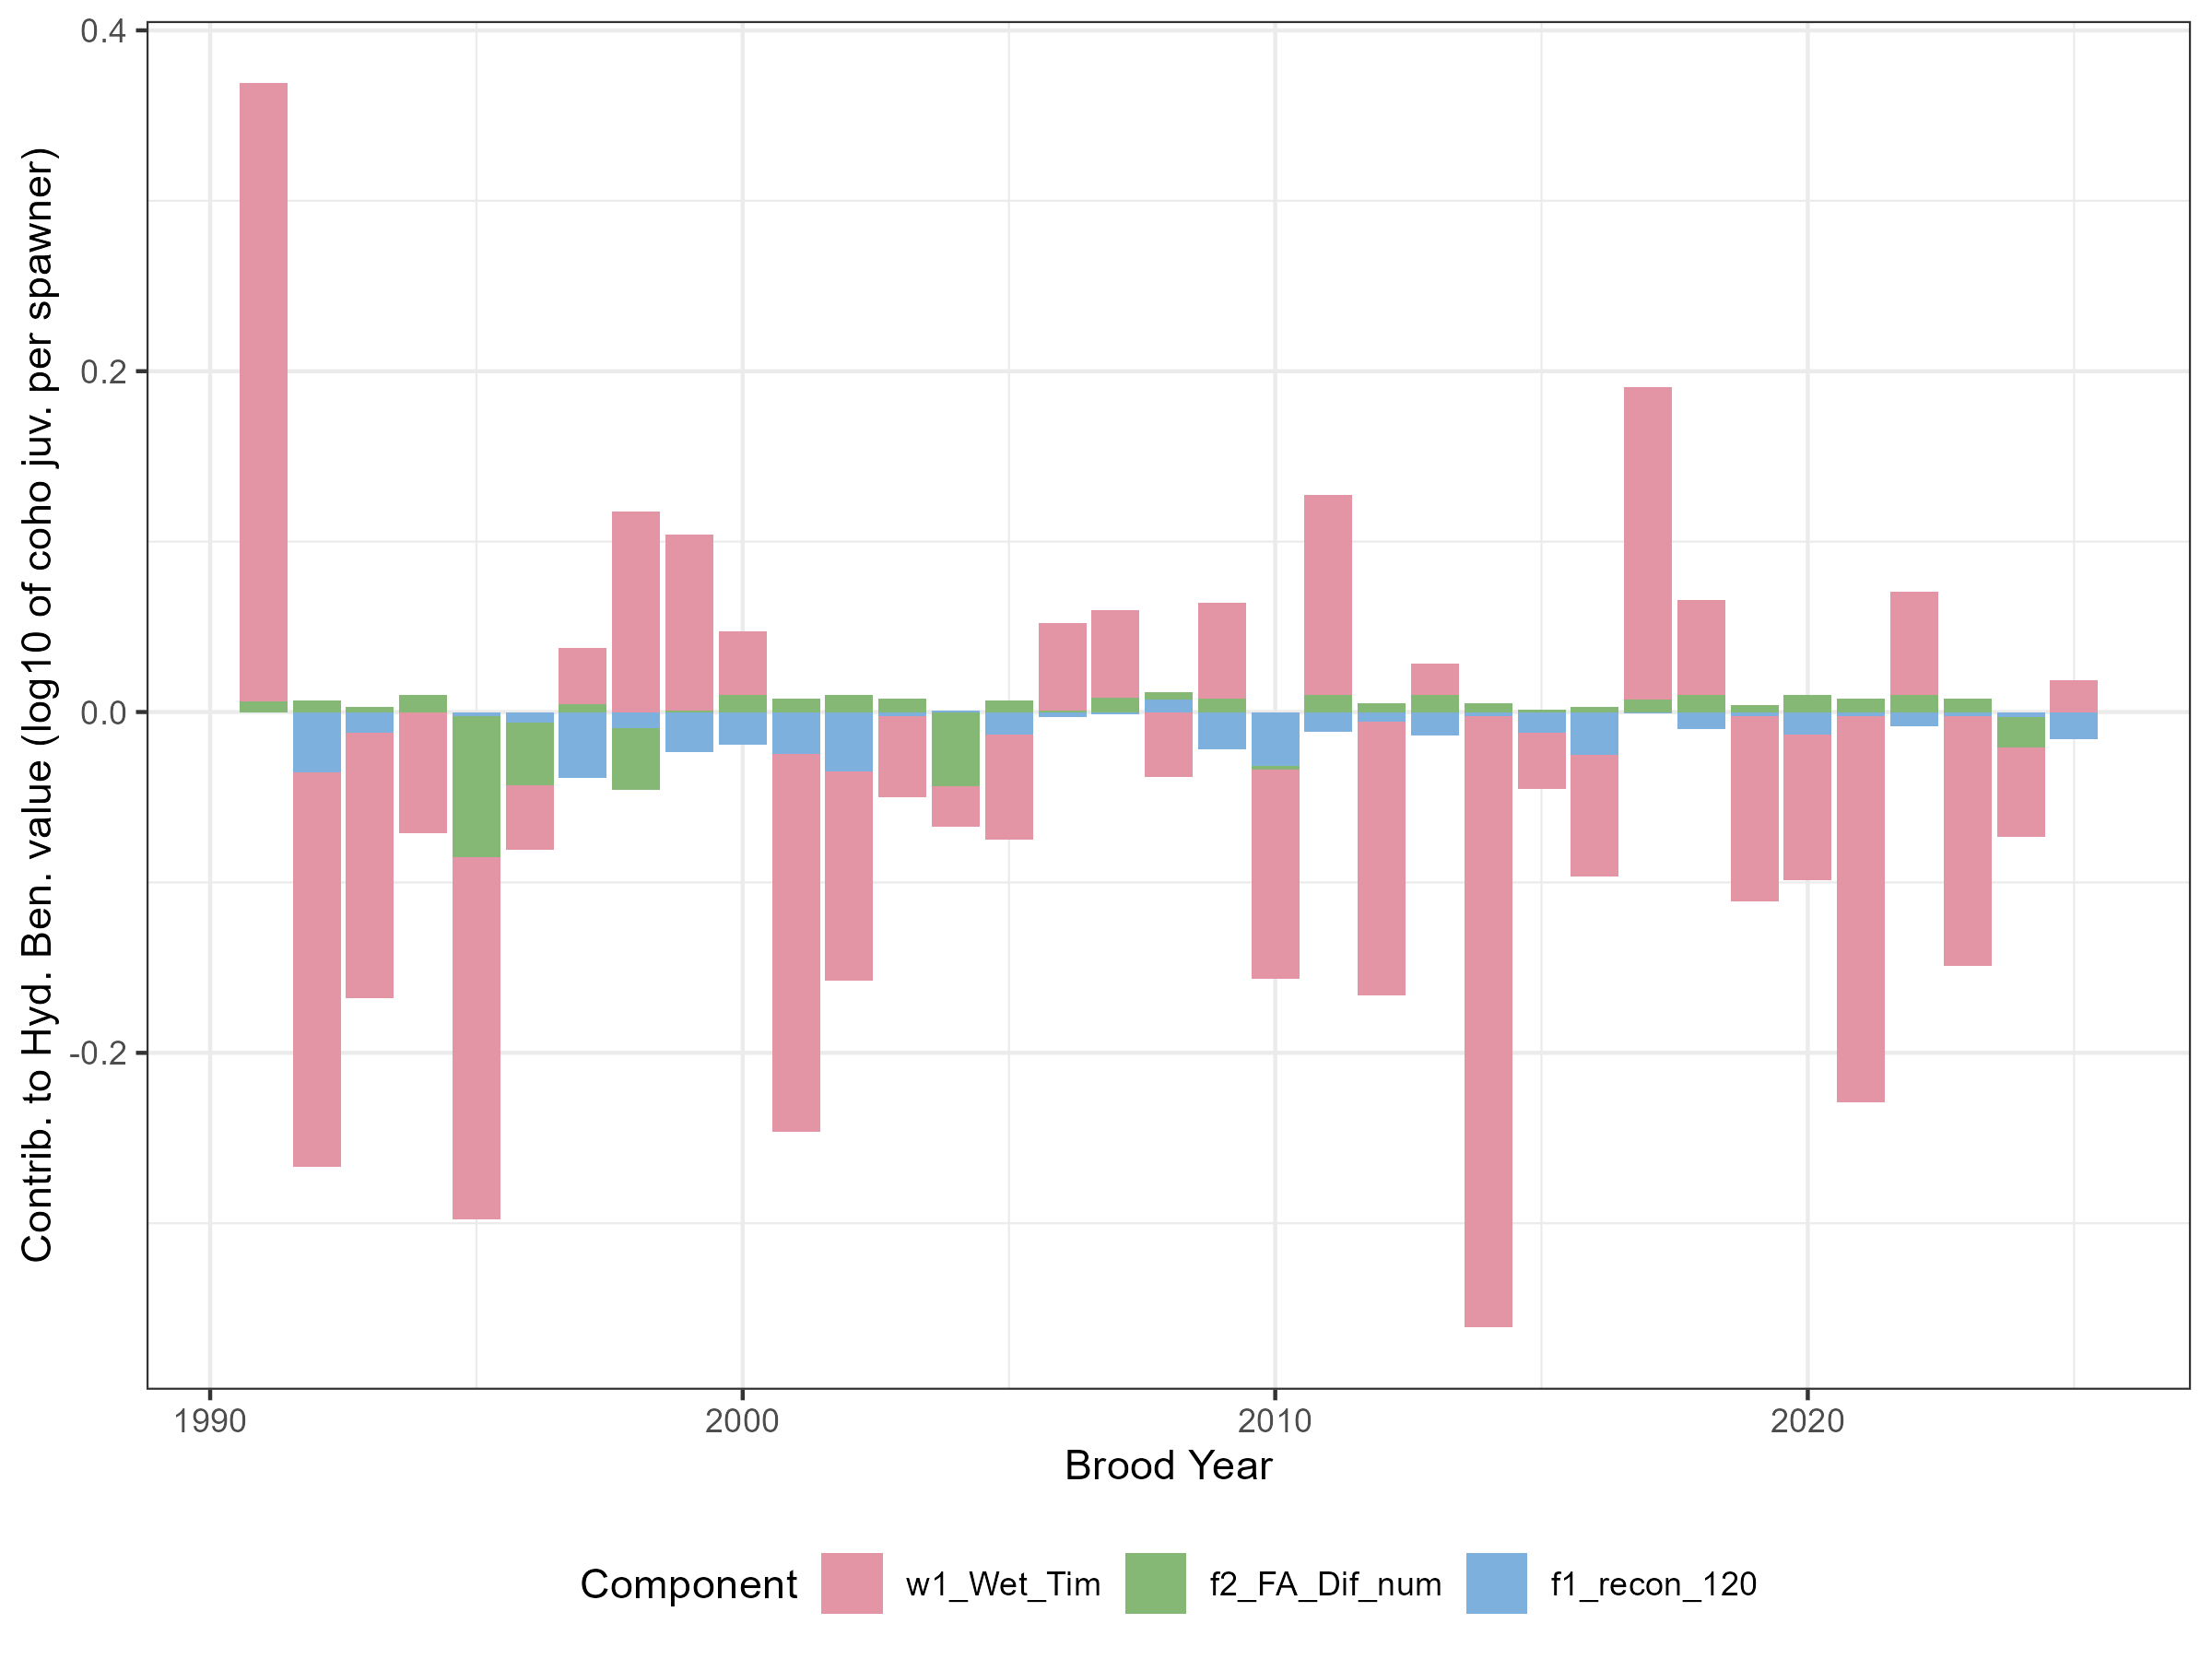Figure S8.
For the base case scenario, contributions to annual Hydrologic Benefit Function B values, by functional flow metric (see Table 1 above; intercept values not shown).

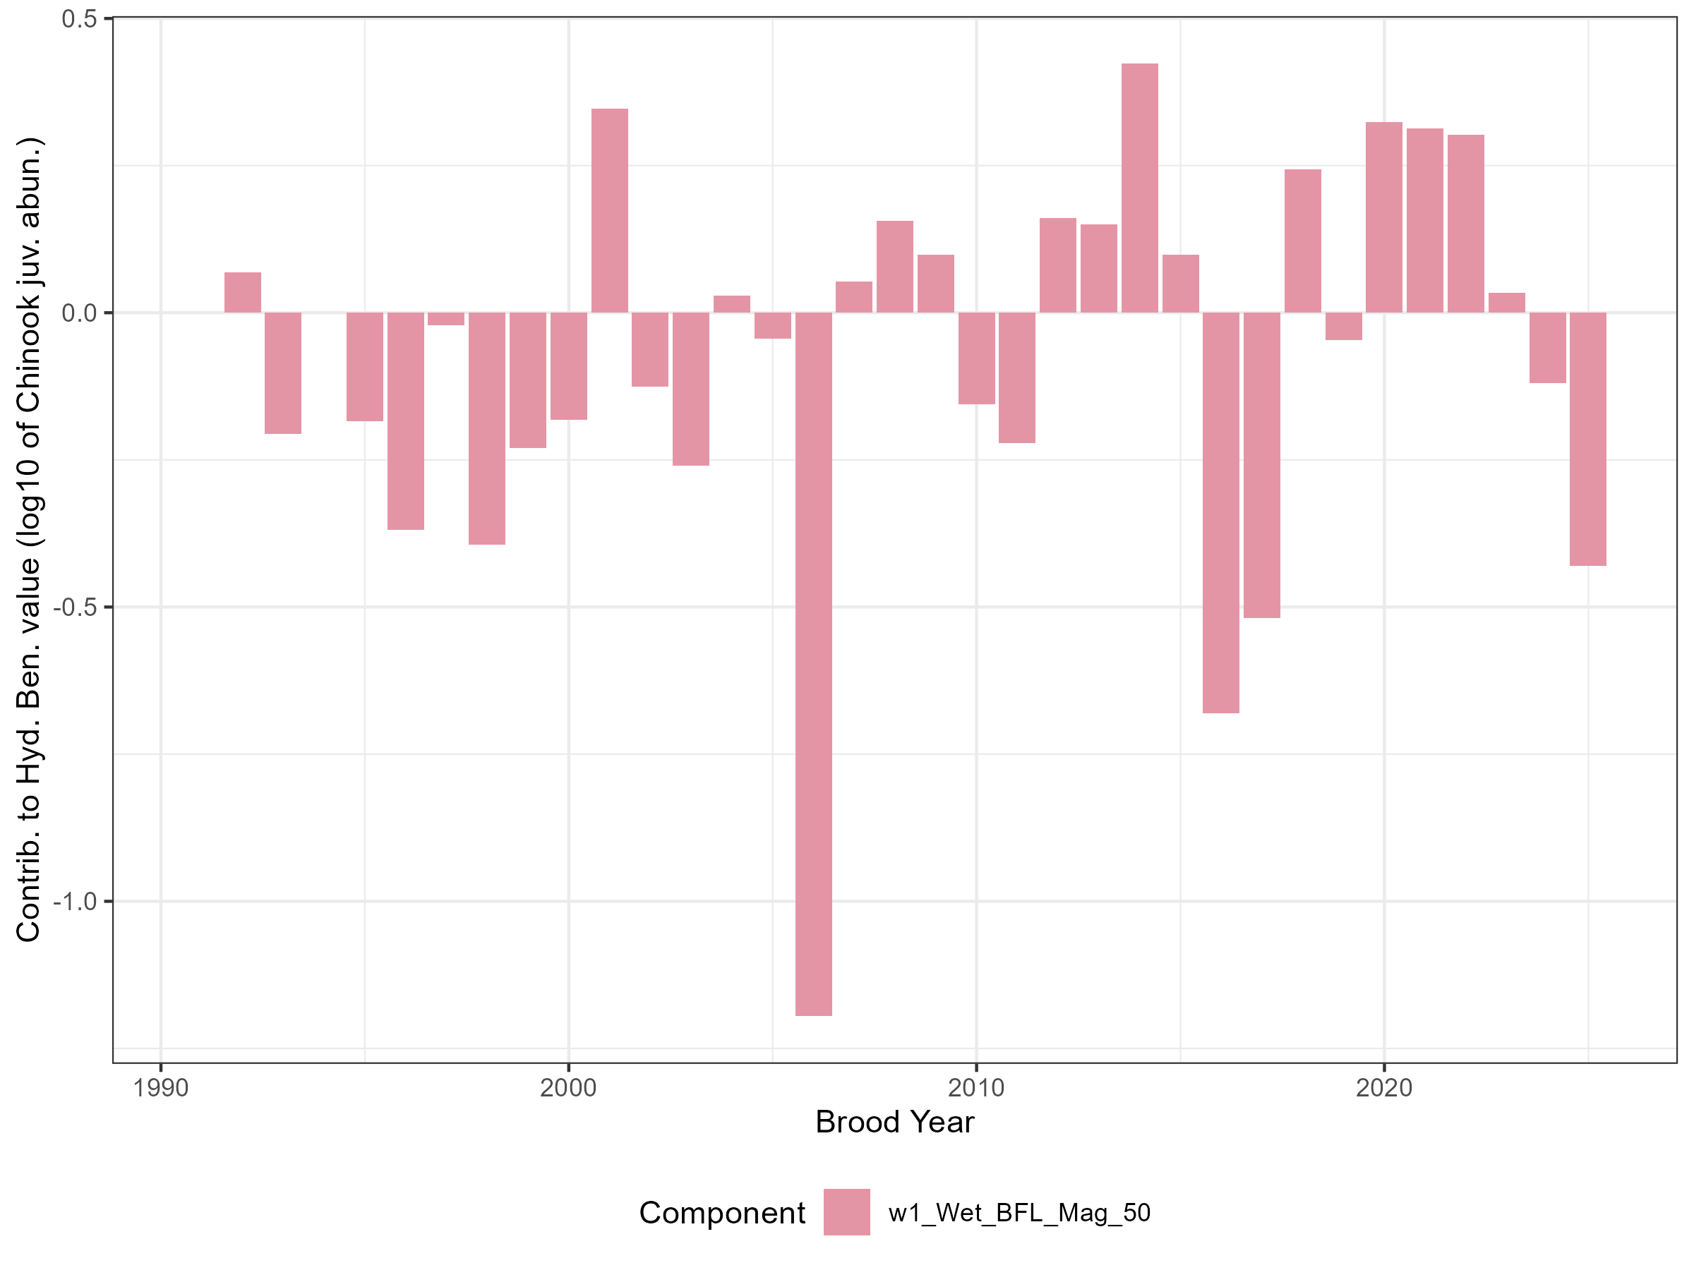Figure S9.
For the base case scenario, contributions to annual Hydrologic Benefit Function C values, by functional flow metric (see Table 1 above; intercept values not shown).

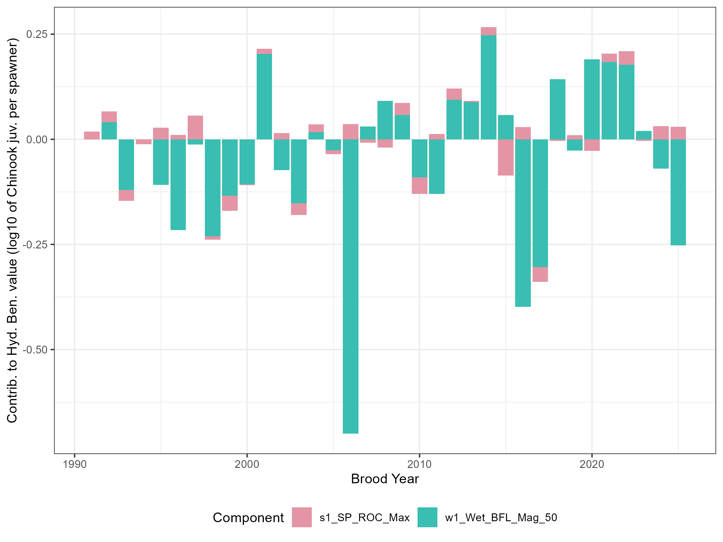Figure S10.
For the base case scenario, contributions to annual Hydrologic Benefit Function D values, by functional flow metric (see Table 1 above; intercept values not shown).

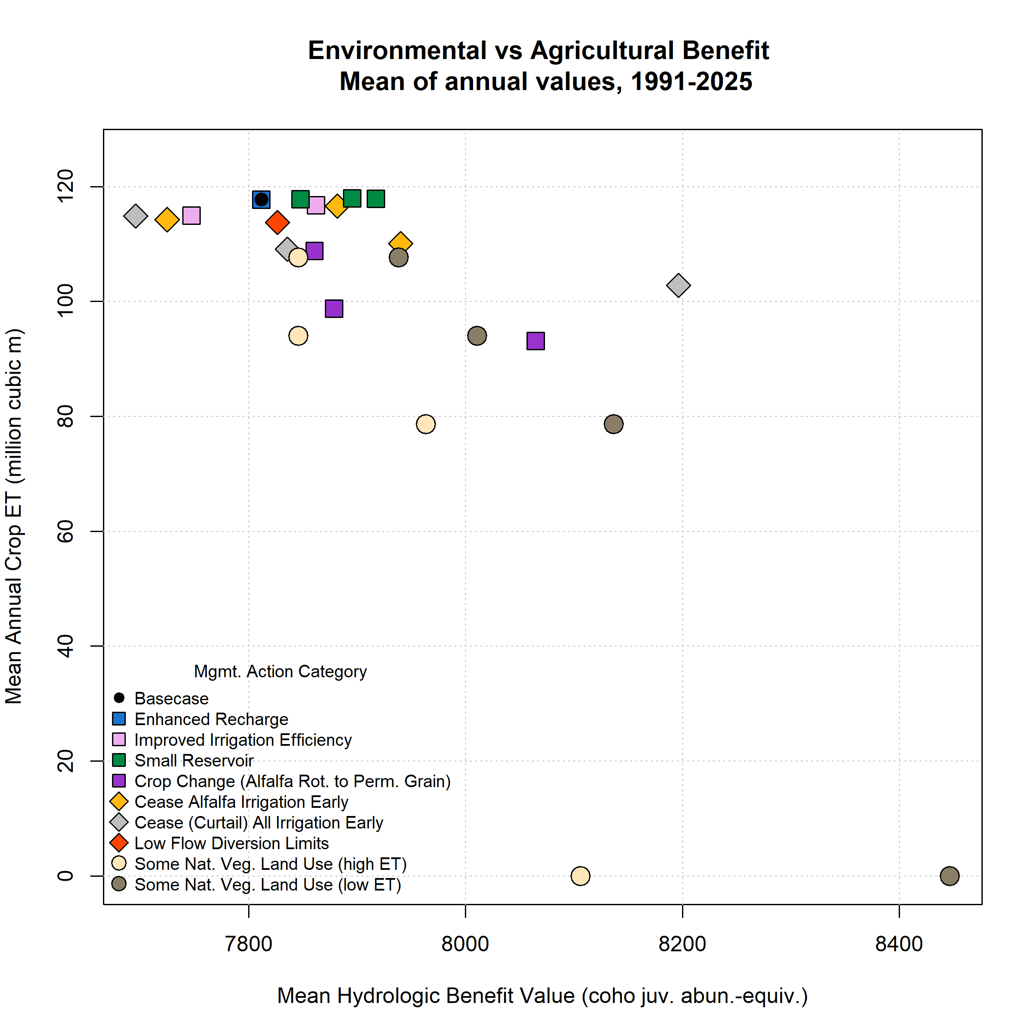Figure S11.
Environmental and agricultural objective function performance (in terms of Hydrologic Benefit A, or HB, value; and crop ET volume) for base case (black circle in upper left) and 25 management scenarios. Symbol x and y coordinates are the average of 35 annual HB and ET values for each scenario over the full model period (water years 1991-2025); for exampe time series of annual values, see previous figure.

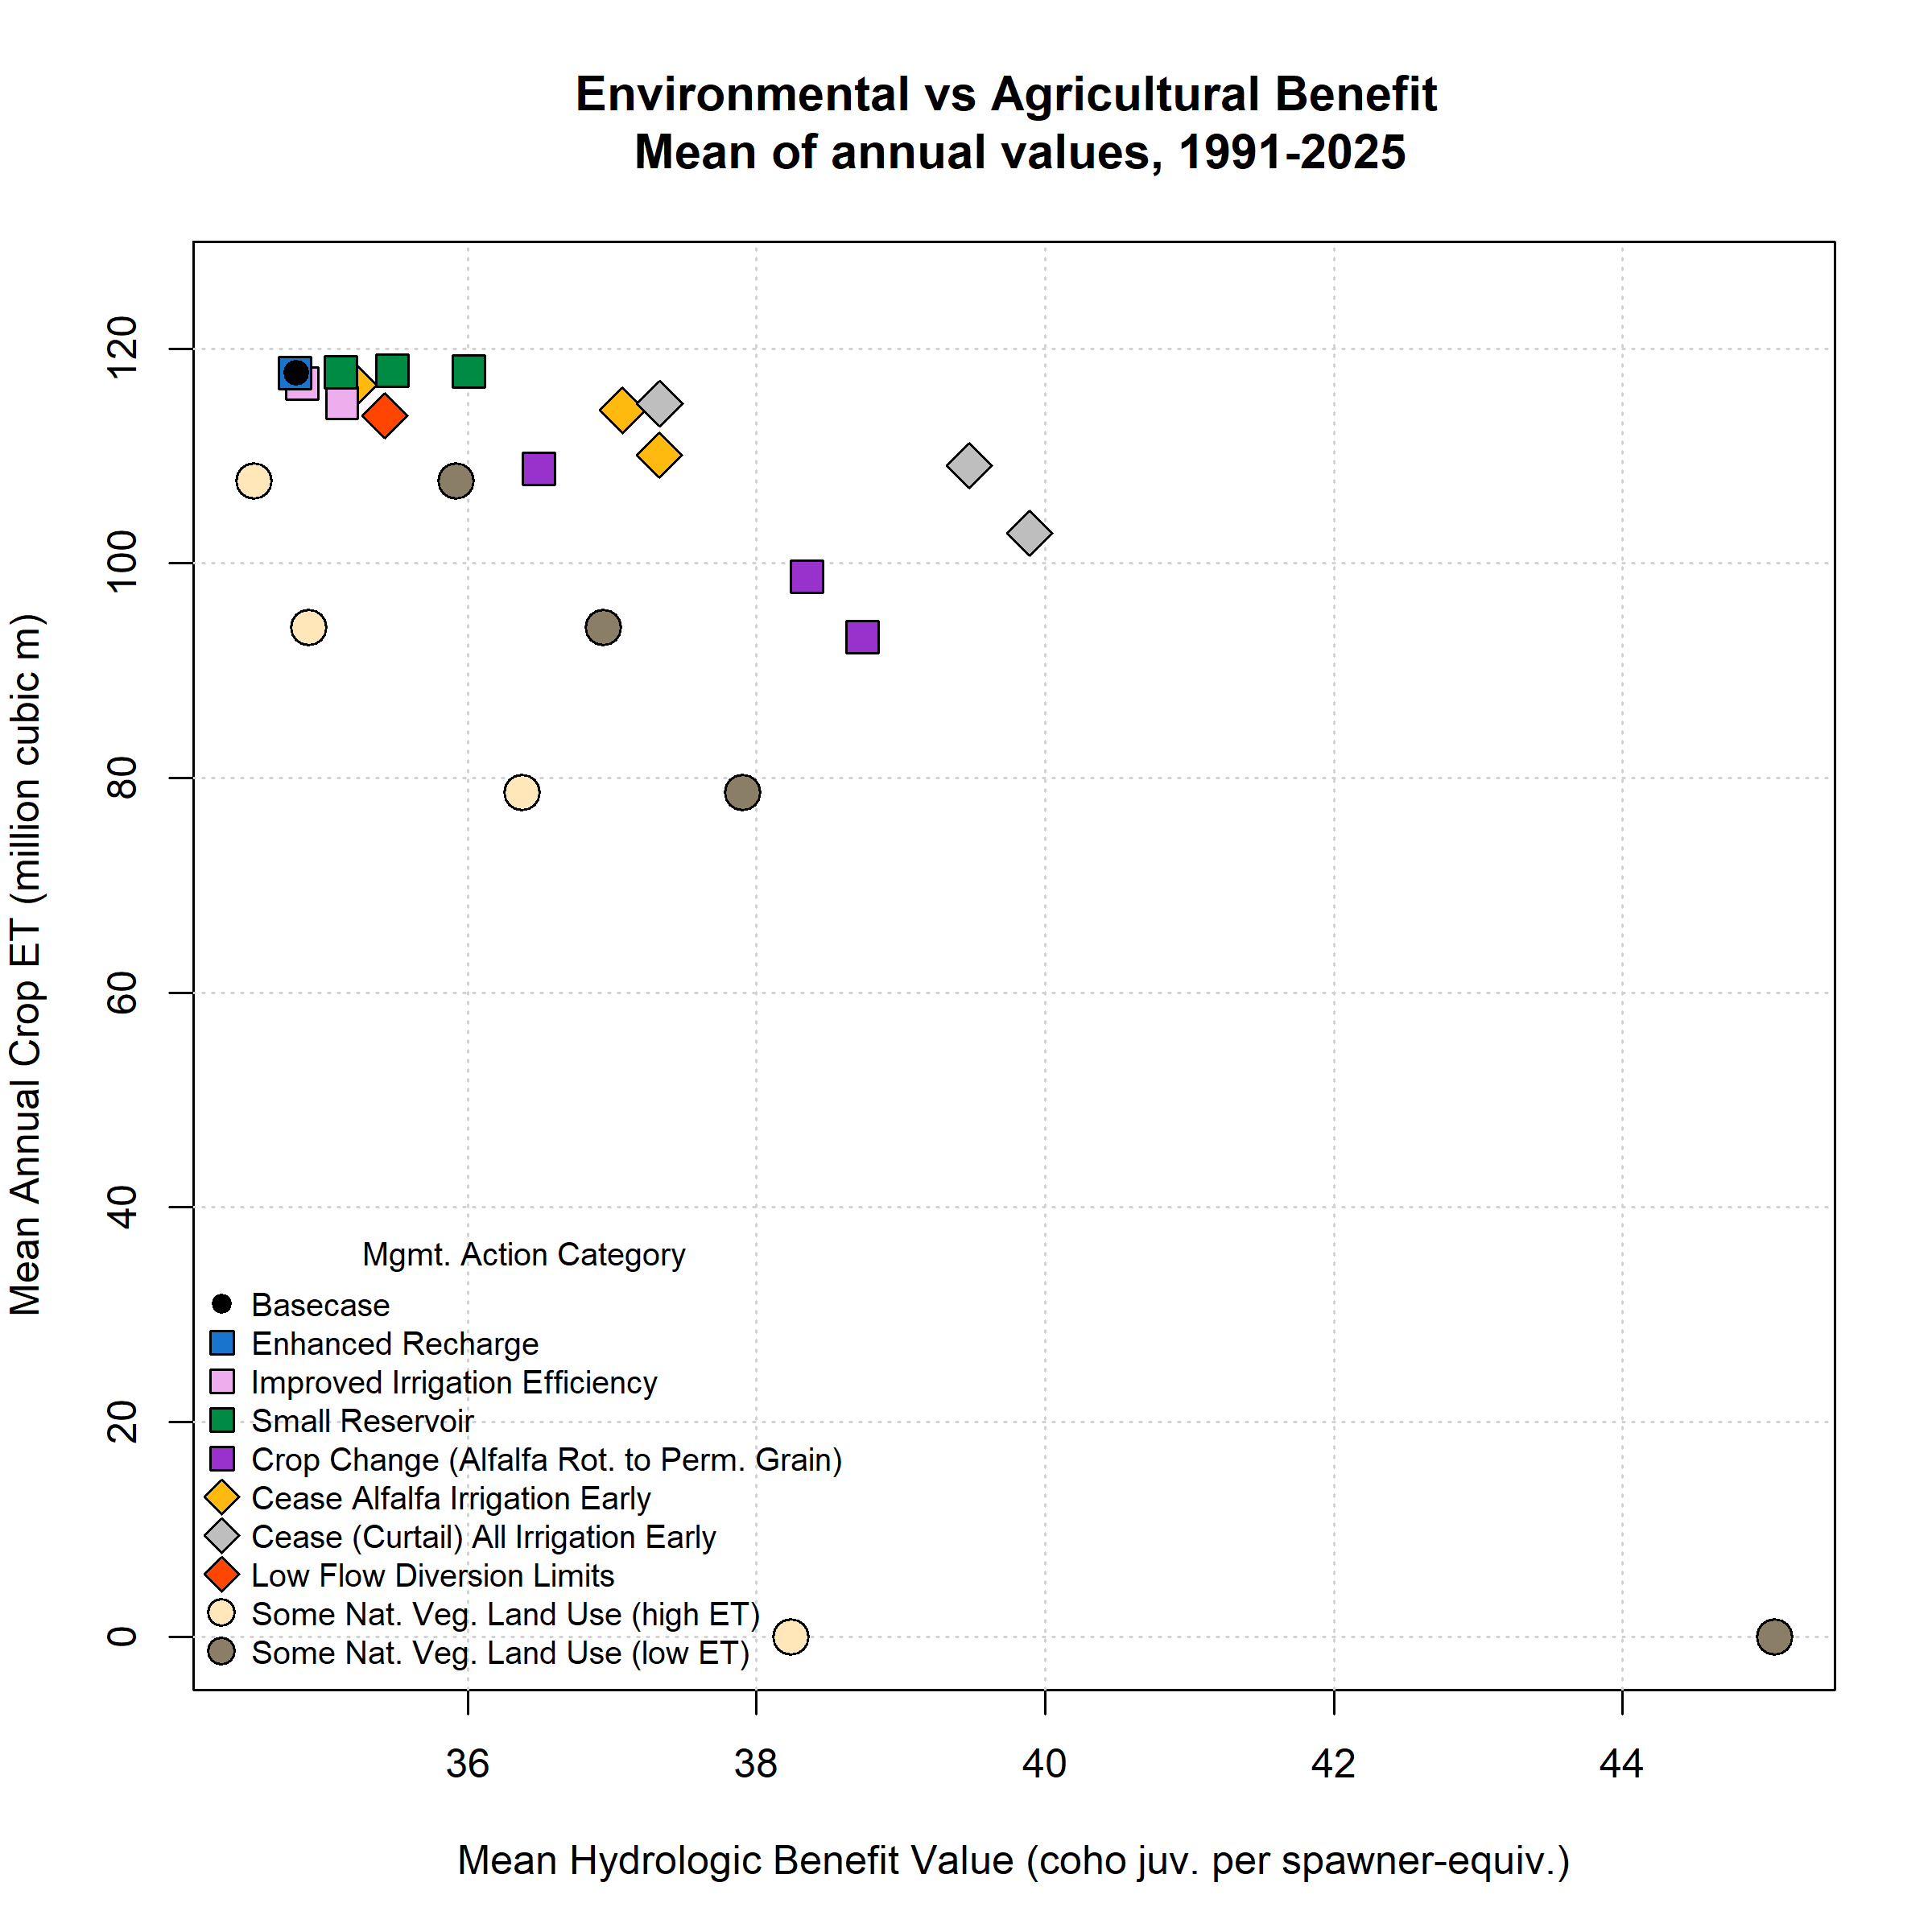Figure S12.
Environmental and agricultural objective function performance (in terms of Hydrologic Benefit B, or HB, value; and crop ET volume) for base case (black circle in upper left) and 25 management scenarios. Symbol x and y coordinates are the average of 35 annual HB and ET values for each scenario over the full model period (water years 1991-2025); for exampe time series of annual values, see previous figure.

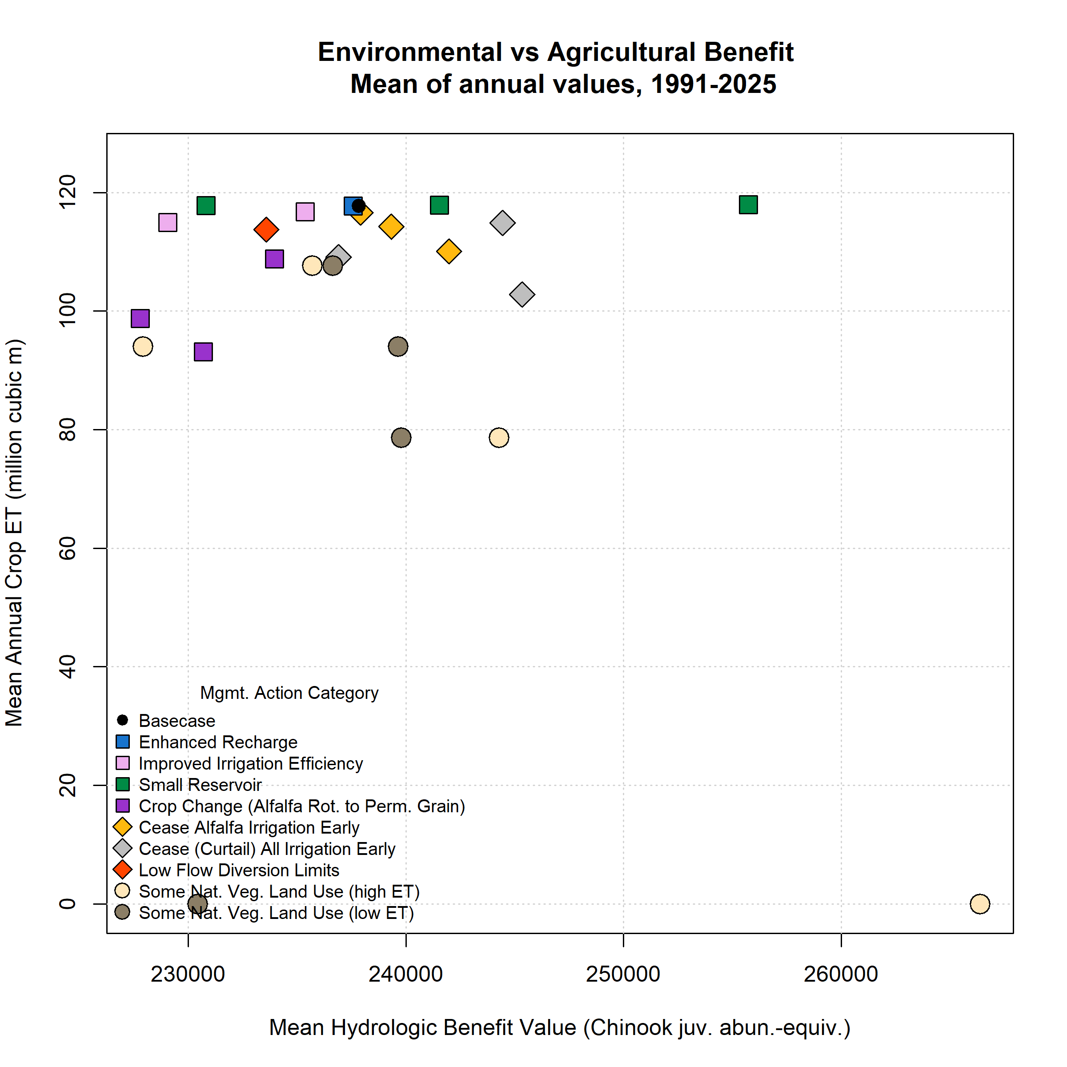Figure S13.
Environmental and agricultural objective function performance (in terms of Hydrologic Benefit C, or HB, value; and crop ET volume) for base case (black circle in upper left) and 25 management scenarios. Symbol x and y coordinates are the average of 35 annual HB and ET values for each scenario over the full model period (water years 1991-2025); for exampe time series of annual values, see previous figure.

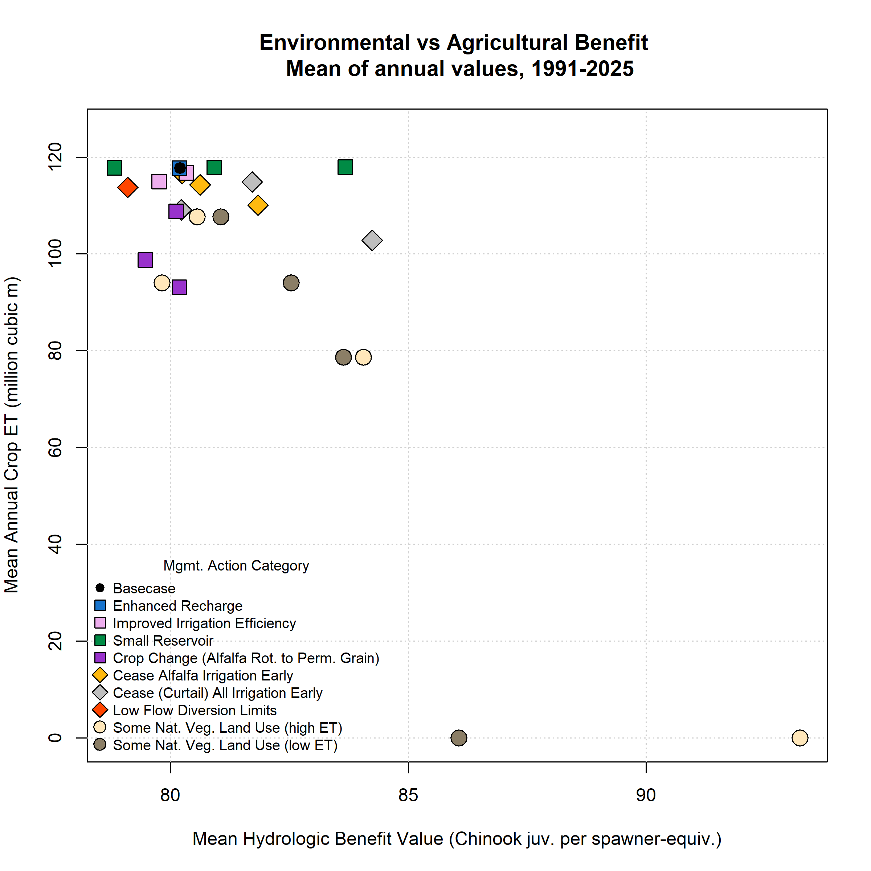Figure S14.
Environmental and agricultural objective function performance (in terms of Hydrologic Benefit D, or HB, value; and crop ET volume) for base case (black circle in upper left) and 25 management scenarios. Symbol x and y coordinates are the average of 35 annual HB and ET values for each scenario over the full model period (water years 1991-2025); for exampe time series of annual values, see previous figure.

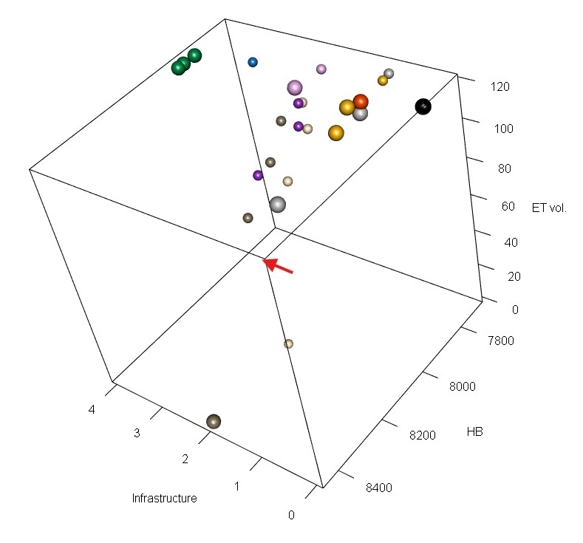

Figure S15.
A three-dimensional scatter plot of the objective function values for base case and 24 management scenarios, averaged over 35 water years (1991-2025). Environmental objective is Hydrologic Benefit Function A. Larger spheres are shown for the Pareto-optimal set of scenarios. Scenario colors correspond to legend in Supplement Figures 3 and 4. The corner corresponding to optimal values of all objective functions (the ‘best’ corner) is highlighted with a red arrow.

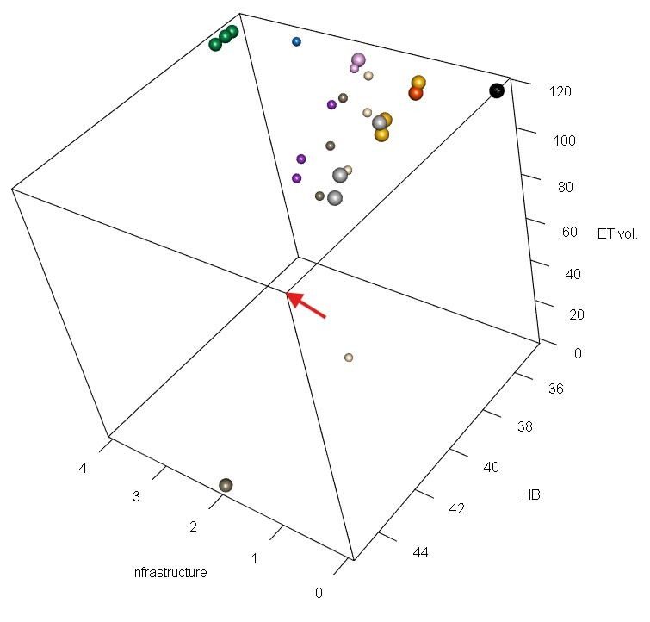

Figure S16.
A three-dimensional scatter plot of the objective function values for base case and 24 management scenarios, averaged over 35 water years (1991-2025). Environmental objective is Hydrologic Benefit Function B. Larger spheres are shown for the Pareto-optimal set of scenarios. Scenario colors correspond to legend in Supplement Figures 3 and 4. The corner corresponding to optimal values of all objective functions (the ‘best’ corner) is highlighted with a red arrow.

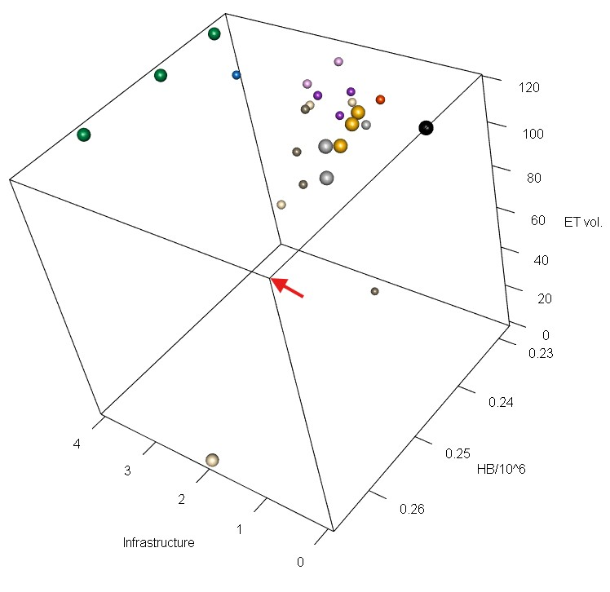

Figure S17.
A three-dimensional scatter plot of the objective function values for base case and 24 management scenarios, averaged over 35 water years (1991-2025). Environmental objective is Hydrologic Benefit Function C. Larger spheres are shown for the Pareto-optimal set of scenarios. Scenario colors correspond to legend in Supplement Figures 3 and 4. The corner corresponding to optimal values of all objective functions (the ‘best’ corner) is highlighted with a red arrow.

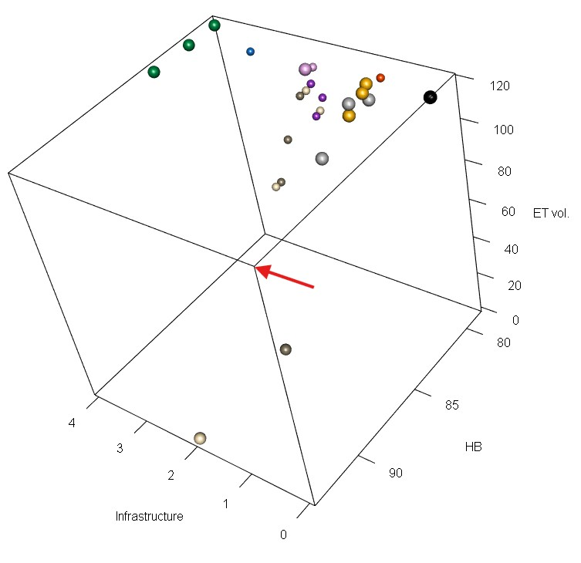

Figure S18.
A three-dimensional scatter plot of the objective function values for base case and 24 management scenarios, averaged over 35 water years (1991-2025). Environmental objective is Hydrologic Benefit Function D. Larger spheres are shown for the Pareto-optimal set of scenarios. Scenario colors correspond to legend in Supplement Figures 3 and 4. The corner corresponding to optimal values of all objective functions (the ‘best’ corner) is highlighted with a red arrow.

Table S1. Coho juvenile abundance.

Coefficients for Hydrologic Benefit Function A, an empirical estimate of ecological services provided to coho salmon by specific functional flows. The predicted value is in units of log10(juvenile abundance) produced, modeled using only hydrological factors.

Predictor | Value | Greater Hydrologic Benefit value associated with
Intercept | 3.872 | Intercept Term
f1_FA_Dif_num | 0.162 | Larger fall flow increase (during parents' spawning)
s1_SP_ROC | -0.020 | Slower rate of change, spring recession (as recent hatchlings)
f2_FA_Dif_num | -0.130 | Smaller fall pulse (as juvenile fish)

Table S2. Coho juveniles per spawner.
Coefficients for the Hydrologic Benefit Function B, an empirical estimate of ecological services provided to coho salmon by specific functional flows. The predicted value is in units of log10(juveniles per spawner) produced, modeled using only hydrological factors.

Predictor | Value | Greater Hydrologic Benefit value associated with
Intercept | 1.592 | Intercept Term
w1_Wet_Tim | -0.007 | Earlier wet season onset (as eggs and fry)
f2_FA_Dif_num | -0.012 | Smaller fall pulse (as juvenile fish)
f1_recon_120 | -0.155 | Earlier fall reconnection (during parents' spawning)

Table S3. Chinook juvenile abundance.
Coefficients for the Hydrologic Benefit Function D, an empirical estimate of ecological services provided to Chinook salmon by specific functional flows. The predicted value is in units of log10(juvenile abundance) produced, modeled using only hydrological factors.

Predictor | Value | Greater Hydrologic Benefit value associated with
Intercept | 5.450 | Intercept Term
w1_Wet_BFL_Mag_50 | -0.309 | Smaller wet season baseflows (as eggs and hatchlings)

Table S4. Chinook juveniles per spawner.
Coefficients for the Hydrologic Benefit Function D, an empirical estimate of ecological services provided to Chinook salmon by specific functional flows. The predicted value is in units of log10(juveniles per spawner) produced, modeled using only hydrological factors.
Predictor | Value | Greater Hydrologic Benefit value associated with
Intercept | 1.944 | Intercept Term
s1_SP_ROC_Max | -0.041 | Slower max. rate of change, spring recession (as outmigrating smolt)
w1_Wet_BFL_Mag_50 | -0.181 | Smaller wet season baseflows (as eggs and hatchlings)

Table S5.
Scenario attributes for 25 scenarios for Hydrologic Benefit (HB) Function A (coho juvenile abundance). Values in the Mean HB and Mean ET columns are averages of 35 annual values for each scenario. Efficiency not calculated for scenarios with no average ET loss.
Scenario ID | Category | Feas. | Mean HB / 1000 | Mean ET | Pareto | Efficiency
basecase | basecase | 0 | 7.81 | 117.76 | Yes | --
alf_curtail_07.15 | AlfIrr | 1 | 7.94 | 110.09 | Yes | 0.25
alf_curtail_07.31 | AlfIrr | 1 | 7.72 | 114.26 | -- | --
alf_curtail_08.15 | AlfIrr | 1 | 7.88 | 116.61 | Yes | 0.92
curtail_all_07.15 | Curtail | 1 | 8.20 | 102.83 | Yes | 0.39
curtail_all_07.31 | Curtail | 1 | 7.84 | 109.13 | Yes | 0.04
curtail_all_08.15 | Curtail | 1 | 7.70 | 114.91 | -- | --
eflows25_div_lims | FlowLims | 1 | 7.83 | 113.75 | Yes | 0.05
grain_12k | CropCh | 2 | 7.88 | 98.75 | -- | 0.05
grain_14k | CropCh | 2 | 8.06 | 93.16 | -- | 0.15
grain_6k | CropCh | 2 | 7.86 | 108.81 | -- | 0.08
irr_eff_0.1 | IrrEff | 2 | 7.86 | 116.74 | Yes | 0.74
irr_eff_0.2 | IrrEff | 2 | 7.75 | 114.98 | -- | --
maxMAR_fields2024 | EnhRch | 3 | 7.81 | 117.75 | -- | --
natveg_high_12k | NatVegH | 2 | 7.96 | 78.66 | -- | 0.06
natveg_high_4k | NatVegH | 2 | 7.85 | 107.70 | -- | 0.05
natveg_high_8k | NatVegH | 2 | 7.85 | 94.02 | -- | 0.02
natveg_high_all | NatVegH | 2 | 8.11 | 0.00 | -- | 0.04
natveg_low_12k | NatVegL | 2 | 8.14 | 78.66 | -- | 0.13
natveg_low_4k | NatVegL | 2 | 7.94 | 107.70 | -- | 0.19
natveg_low_8k | NatVegL | 2 | 8.01 | 94.02 | -- | 0.13
natveg_low_all | NatVegL | 2 | 8.45 | 0.00 | Yes | 0.08
reservoir_etna | Res | 4 | 7.92 | 117.87 | Yes | --
reservoir_french | Res | 4 | 7.85 | 117.84 | Yes | --
reservoir_shackleford | Res | 4 | 7.90 | 117.98 | Yes | --

Table S6.
Scenario attributes for 25 scenarios for Hydrologic Benefit (HB) Function B (coho juveniles per spawner). Values in the Mean HB and Mean ET columns are averages of 35 annual values for each scenario. Efficiency not calculated for scenarios with no average ET loss.
Scenario ID | Category | Feas. | Mean HB | Mean ET | Pareto | Efficiency
basecase | basecase | 0 | 34.81 | 117.76 | Yes | --
alf_curtail_07.15 | AlfIrr | 1 | 37.33 | 110.09 | Yes | 1.11
alf_curtail_07.31 | AlfIrr | 1 | 37.07 | 114.26 | Yes | 2.19
alf_curtail_08.15 | AlfIrr | 1 | 35.21 | 116.61 | Yes | 1.19
curtail_all_07.15 | Curtail | 1 | 39.89 | 102.83 | Yes | 1.15
curtail_all_07.31 | Curtail | 1 | 39.48 | 109.13 | Yes | 1.83
curtail_all_08.15 | Curtail | 1 | 37.33 | 114.91 | Yes | 2.99
eflows25_div_lims | FlowLims | 1 | 35.43 | 113.75 | Yes | 0.52
grain_12k | CropCh | 2 | 38.35 | 98.75 | -- | 0.63
grain_14k | CropCh | 2 | 38.74 | 93.16 | -- | 0.54
grain_6k | CropCh | 2 | 36.49 | 108.81 | -- | 0.63
irr_eff_0.1 | IrrEff | 2 | 34.85 | 116.74 | Yes | 0.14
irr_eff_0.2 | IrrEff | 2 | 35.13 | 114.98 | -- | 0.39
maxMAR_fields2024 | EnhRch | 3 | 34.81 | 117.75 | -- | --
natveg_high_12k | NatVegH | 2 | 36.37 | 78.66 | -- | 0.14
natveg_high_4k | NatVegH | 2 | 34.52 | 107.70 | -- | --
natveg_high_8k | NatVegH | 2 | 34.90 | 94.02 | -- | 0.01
natveg_high_all | NatVegH | 2 | 38.24 | 0.00 | -- | 0.1
natveg_low_12k | NatVegL | 2 | 37.91 | 78.66 | -- | 0.27
natveg_low_4k | NatVegL | 2 | 35.92 | 107.70 | -- | 0.37
natveg_low_8k | NatVegL | 2 | 36.94 | 94.02 | -- | 0.3
natveg_low_all | NatVegL | 2 | 45.05 | 0.00 | Yes | 0.29
reservoir_etna | Res | 4 | 36.01 | 117.87 | Yes | --
reservoir_french | Res | 4 | 35.12 | 117.84 | Yes | --
reservoir_shackleford | Res | 4 | 35.48 | 117.98 | Yes | --

Table S7.
Scenario attributes for 25 scenarios for Hydrologic Benefit (HB) Function C (Chinook juv. abundance). Values in the Mean HB and Mean ET columns are averages of 35 annual values for each scenario. Efficiency not calculated for scenarios with no average ET loss.
Scenario ID | Category | Feas. | Mean HB / 1000 | Mean ET | Pareto | Efficiency
basecase | basecase | 0 | 237.85 | 117.76 | Yes | --
alf_curtail_07.15 | AlfIrr | 1 | 241.99 | 110.09 | Yes | 0.27
alf_curtail_07.31 | AlfIrr | 1 | 239.33 | 114.26 | Yes | 0.21
alf_curtail_08.15 | AlfIrr | 1 | 237.93 | 116.61 | Yes | 0.04
curtail_all_07.15 | Curtail | 1 | 245.35 | 102.83 | Yes | 0.25
curtail_all_07.31 | Curtail | 1 | 236.91 | 109.13 | -- | --
curtail_all_08.15 | Curtail | 1 | 244.45 | 114.91 | Yes | 1.15
eflows25_div_lims | FlowLims | 1 | 233.59 | 113.75 | -- | --
grain_12k | CropCh | 2 | 227.80 | 98.75 | -- | --
grain_14k | CropCh | 2 | 230.70 | 93.16 | -- | --
grain_6k | CropCh | 2 | 233.96 | 108.81 | -- | --
irr_eff_0.1 | IrrEff | 2 | 235.38 | 116.74 | -- | --
irr_eff_0.2 | IrrEff | 2 | 229.06 | 114.98 | -- | --
maxMAR_fields2024 | EnhRch | 3 | 237.59 | 117.75 | -- | --
natveg_high_12k | NatVegH | 2 | 244.28 | 78.66 | -- | 0.08
natveg_high_4k | NatVegH | 2 | 235.70 | 107.70 | -- | --
natveg_high_8k | NatVegH | 2 | 227.92 | 94.02 | -- | --
natveg_high_all | NatVegH | 2 | 266.37 | 0.00 | Yes | 0.12
natveg_low_12k | NatVegL | 2 | 239.78 | 78.66 | -- | 0.02
natveg_low_4k | NatVegL | 2 | 236.64 | 107.70 | -- | --
natveg_low_8k | NatVegL | 2 | 239.65 | 94.02 | -- | 0.04
natveg_low_all | NatVegL | 2 | 230.43 | 0.00 | -- | --
reservoir_etna | Res | 4 | 241.54 | 117.87 | Yes | --
reservoir_french | Res | 4 | 230.83 | 117.84 | Yes | --
reservoir_shackleford | Res | 4 | 255.73 | 117.98 | Yes | --

Table S8.
Scenario attributes for 25 scenarios for Hydrologic Benefit (HB) Function D (Chinook juv. per spawner). Values in the Mean HB and Mean ET columns are averages of 35 annual values for each scenario. Efficiency not calculated for scenarios with no average ET loss.
Scenario ID | Category | Feas. | Mean HB | Mean ET | Pareto | Efficiency
basecase | basecase | 0 | 80.20 | 117.76 | Yes | --
alf_curtail_07.15 | AlfIrr | 1 | 81.84 | 110.09 | Yes | 0.31
alf_curtail_07.31 | AlfIrr | 1 | 80.63 | 114.26 | Yes | 0.18
alf_curtail_08.15 | AlfIrr | 1 | 80.25 | 116.61 | Yes | 0.06
curtail_all_07.15 | Curtail | 1 | 84.24 | 102.83 | Yes | 0.4
curtail_all_07.31 | Curtail | 1 | 80.23 | 109.13 | Yes | 0
curtail_all_08.15 | Curtail | 1 | 81.72 | 114.91 | Yes | 0.78
eflows25_div_lims | FlowLims | 1 | 79.11 | 113.75 | -- | --
grain_12k | CropCh | 2 | 79.48 | 98.75 | -- | --
grain_14k | CropCh | 2 | 80.19 | 93.16 | -- | --
grain_6k | CropCh | 2 | 80.12 | 108.81 | -- | --
irr_eff_0.1 | IrrEff | 2 | 80.33 | 116.74 | Yes | 0.19
irr_eff_0.2 | IrrEff | 2 | 79.76 | 114.98 | -- | --
maxMAR_fields2024 | EnhRch | 3 | 80.19 | 117.75 | -- | --
natveg_high_12k | NatVegH | 2 | 84.05 | 78.66 | -- | 0.14
natveg_high_4k | NatVegH | 2 | 80.56 | 107.70 | -- | 0.05
natveg_high_8k | NatVegH | 2 | 79.83 | 94.02 | -- | --
natveg_high_all | NatVegH | 2 | 93.23 | 0.00 | Yes | 0.16
natveg_low_12k | NatVegL | 2 | 83.63 | 78.66 | -- | 0.13
natveg_low_4k | NatVegL | 2 | 81.06 | 107.70 | -- | 0.13
natveg_low_8k | NatVegL | 2 | 82.54 | 94.02 | -- | 0.14
natveg_low_all | NatVegL | 2 | 86.06 | 0.00 | Yes | 0.07
reservoir_etna | Res | 4 | 80.92 | 117.87 | Yes | --
reservoir_french | Res | 4 | 78.83 | 117.84 | Yes | --
reservoir_shackleford | Res | 4 | 83.67 | 117.98 | Yes | --

Data Set S1.

Annual values of the functional flow metrics, subsets of which are used as predictors in Hydrologic Benefit Function A, in base case and three alfalfa scenarios. To see the daily flow data from which these functional flows are calculated, see Figure S2.

Data Set S2.

Annual values of the functional flow metrics, subsets of which are used as predictors in Hydrologic Benefit Function B, in base case and three alfalfa scenarios. To see the daily flow data from which these functional flows are calculated, see Figure S2.

Data Set S3.

Annual values of the functional flow metrics, subsets of which are used as predictors in Hydrologic Benefit Function C, in base case and three alfalfa scenarios. To see the daily flow data from which these functional flows are calculated, see Figure S2.

Data Set S4.

Annual values of the functional flow metrics, subsets of which are used as predictors in Hydrologic Benefit Function D, in base case and three alfalfa scenarios. To see the daily flow data from which these functional flows are calculated, see Figure S2.

Movies S1-S4.

Point colors correspond to colors in the legend below:



Movie S1.

A three-dimensional scatter plot of the objective function values (environmental objective as Hydrologic Benefit Function A, as well as agriculture and cost objectives) for base case and 24 management scenarios, averaged over 35 water years (1991-2025). Larger spheres are shown for the Pareto-optimal set of scenarios.

Movie S2.

A three-dimensional scatter plot of the objective function values (environmental objective as Hydrologic Benefit Function B, as well as agriculture and cost objectives) for base case and 24 management scenarios, averaged over 35 water years (1991-2025). Larger spheres are shown for the Pareto-optimal set of scenarios.

Movie S3.

A three-dimensional scatter plot of the objective function values (environmental objective as Hydrologic Benefit Function C, as well as agriculture and cost objectives) for base case and 24 management scenarios, averaged over 35 water years (1991-2025). Larger spheres are shown for the Pareto-optimal set of scenarios.

Movie S4.

A three-dimensional scatter plot of the objective function values (environmental objective as Hydrologic Benefit Function D, as well as agriculture and cost objectives) for base case and 24 management scenarios, averaged over 35 water years (1991-2025). Larger spheres are shown for the Pareto-optimal set of scenarios.

